CS 475 Project #2

1. **Tell what machine you ran this on**
   * I ran the code in the flip engineering server (flip.engr.oregonstate.edu).
2. **What do you think the actual volume is?**
   * It seems that the actual volume might be around 6.48 based on numerous of tests.
3. **Show the performances you achieved in tables and graphs as a function of NUMNODES and NUMT**

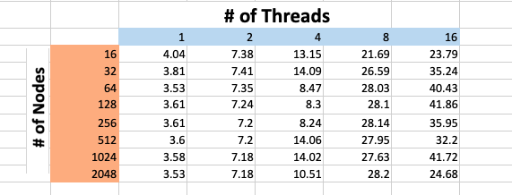

1. **What patterns are you seeing in the speeds?**
   * Based on these two graphs, there seems to be a correlation between the number of threads and speed. Generally speaking, using more threads should result with higher speeds because more calculations can be done in a parallel format given more threads. However, there are some cases where the speed is higher or lower than one expected. One noticeable example would be on the first graph. With 16 threads in used, the speed decreased drastically when going from 1024 nodes to 2048 nodes; it dropped from 40ish megaHeights/second to around 25ish megaHeights/second. Another example would be when using 4 threads and we can see the speed dropped in the middle, and then it picks back up towards the end.
2. **Why do you think it is behaving this way?**
   * These kinds of unusual results possibly coming from not enough threads being created for execution. After all, there were lots of users on the flip server and lots of programs were running during my testing period, which can cause the result different than expected.
3. **What is the Parallel Fraction for this application, using the Inverse Amdahl equation?**
   * $F_{Parallel }= \frac{n}{n-1}(1-\frac{1}{speedup})$, and $Speedup = \frac{P_{n}}{P_{1}}$

Let n = 16, then $Speedup = \frac{24.68}{3.53} ≅6.9915$.

With $F_{Parallel }= \frac{n}{n-1}\left(1-\frac{1}{speedup}\right)= \frac{16}{15}\left(1-\frac{1}{6.9915}\right)≅0.9141$

1. **Given that Parallel Fraction, what is the maximum speed-up you could *ever* get?**

${Speedup}_{Max}= \frac{1}{1-F_{Parallel}}=\frac{1}{1-0.9141}≅11.6414$